**SKILL LEARNT: REACT (WEEK 6)**

**EXERCISE 1: REACTJS-HOL**

STEP 1: Firstly, to create the React App we need to install Node.js and npm through the following link. We can verify installation by typing node -v and npm -v and view the version. If the version shows then it is confirmed that the installation is successful.

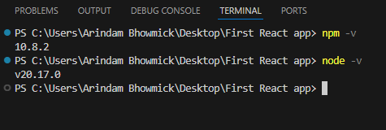

STEP 2: Then we Install Create-react-app by running the following command in the command prompt: npm install -g create-react-app.

STEP 3: Then we create a React Application with the name of “myfirstreact”, by using the command npx create-react-app myfirstreact.

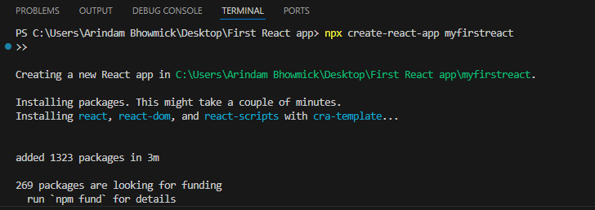

STEP 3: Once the app is created, we navigate to that folder by using cd myfirstreact.

STEP 4: Under src folder in App.js we write the code “Welcome to the first session of React”. The code for it is given below

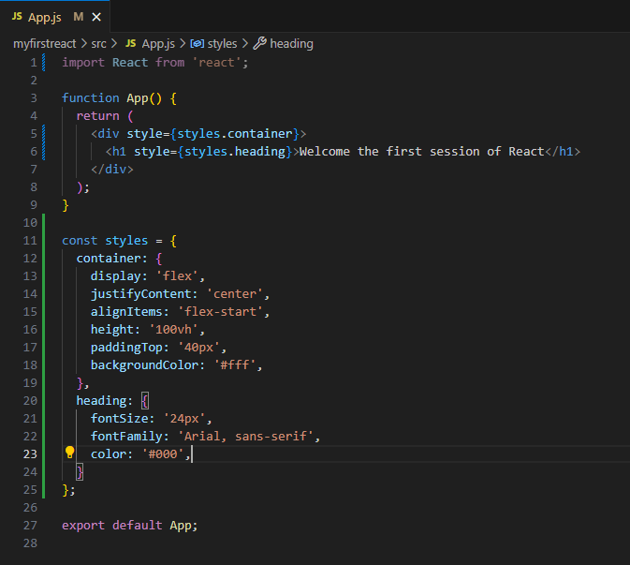

STEP 5: Once the code is written, we run the React Application by using the following command “npm start”.

STEP 6: The output is visible in “localhost:3000”. It is shown below

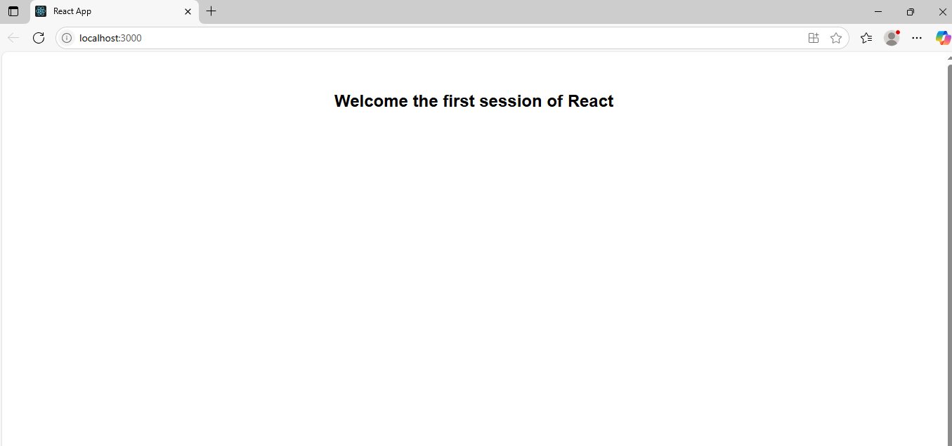

**EXERCISE 2: REACTJS-HOL**

STEP 1: We first create the React app using the command npx create-react-app StudentApp as given. But we find that we cannot create a project using capital letters. So, we change the name to studentapp.

STEP 2: Under src folder we create a new folder called Components and inside that we create three different files named “Home.js”, “Contact.js” and “About.js”.

STEP 3: The code for Home.js is given below

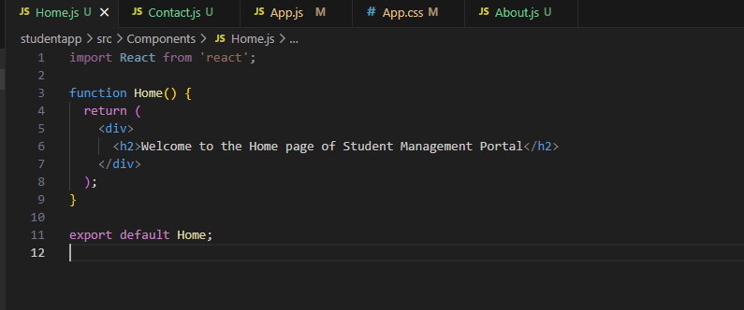

STEP 4: The code for About.js is given below

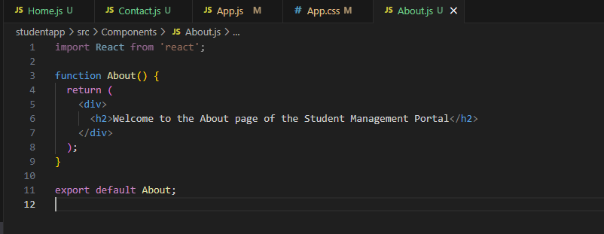

STEP 5: The code for Contact.js is given below

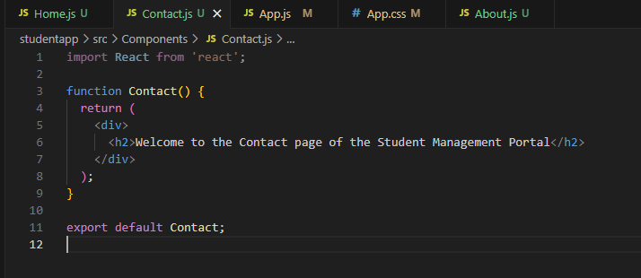

STEP 6: Then we edit the App.js file to invoke the Home, About and Contact sections. The code for App.js is given below

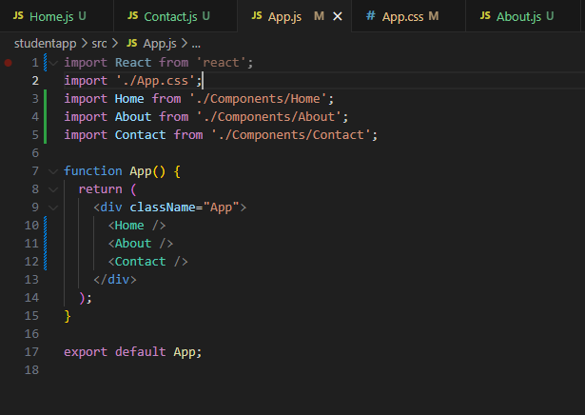

STEP 7: In order to maintain the styling as desired we added some styling to App.css. The code for it is given below

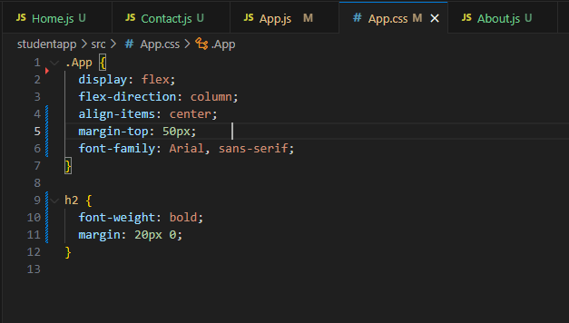

STEP 8: In order to run the React app we use the command “npm start”.

STEP 9: The output is visible in “localhost:3000”. It is shown below

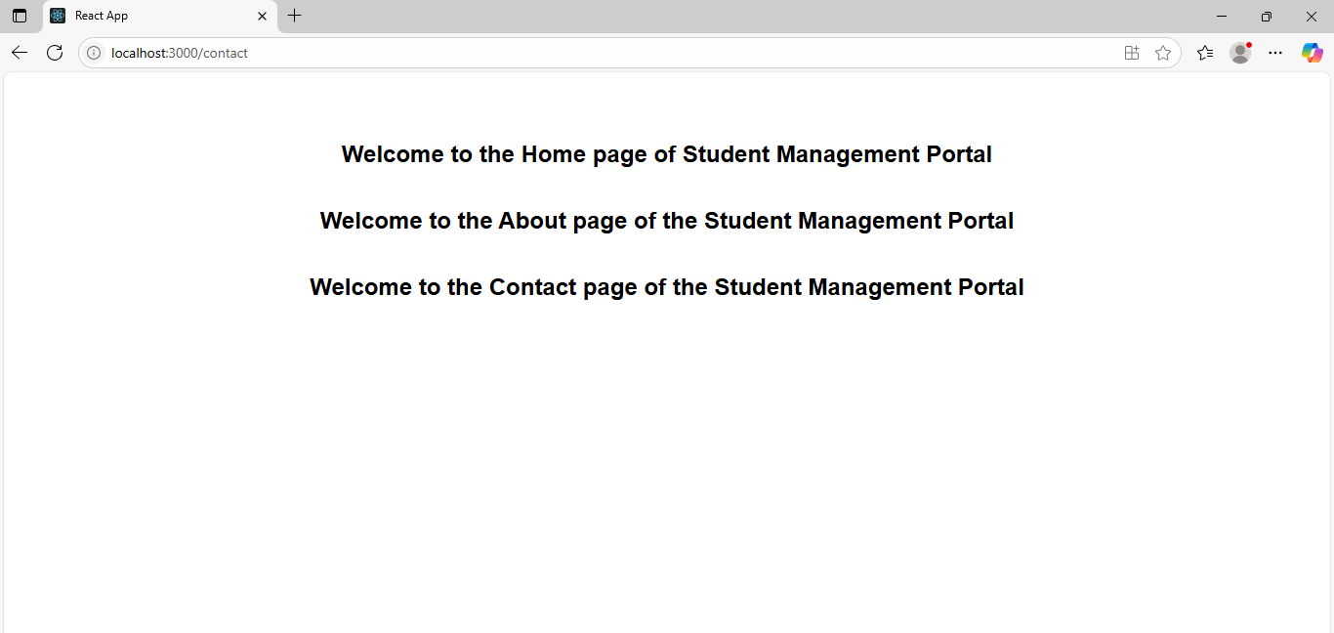

**EXERCISE 3: REACTJS-HOL**

STEP 1: We first create the React app using the command npx create-react-app scorecalculatorapp as given

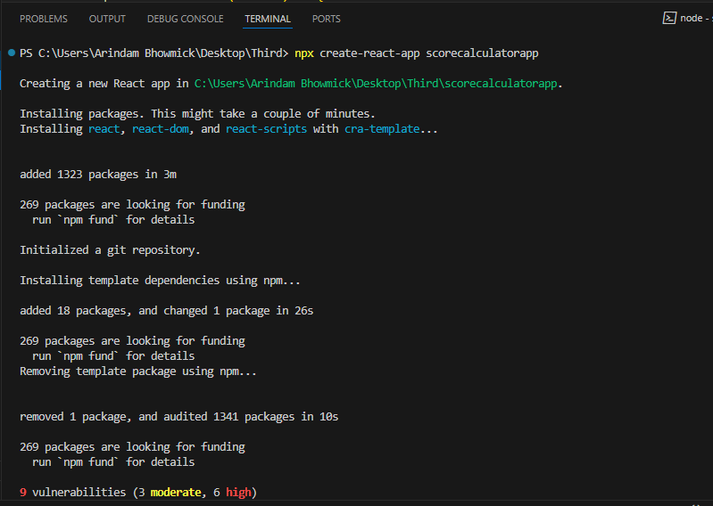

STEP 2: As the react app is created,w e create a new folder under src folder named “Components”. Under Components we create a new file named “CalculateScore.js”. The code for “CalculateScore.js” is shown below

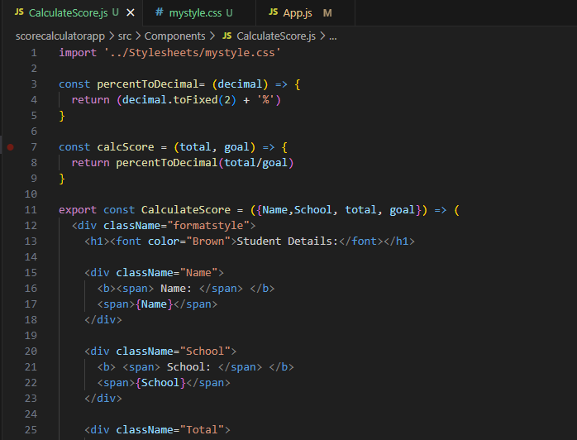

Continued….

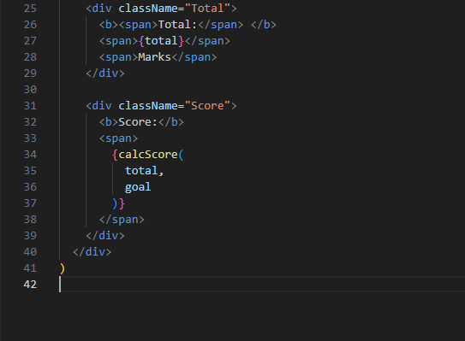

STEP 3: Under src we create a new folder under folder named “Stylesheets”. Under Stylesheets we create a new file named “mystyle.css”. The code for “mystyle.css” is shown below

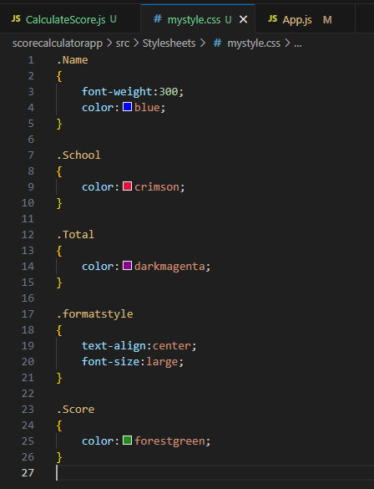

STEP 4: Then we edit the App.js file to add these sections. The code for App.js is shown below

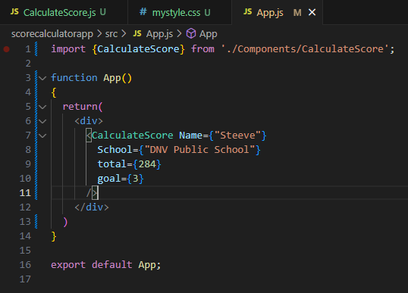

STEP 5: Then we run the React App by using the command “npm start”.

STEP 6: The output is visible in “localhost:3000”. It is shown below

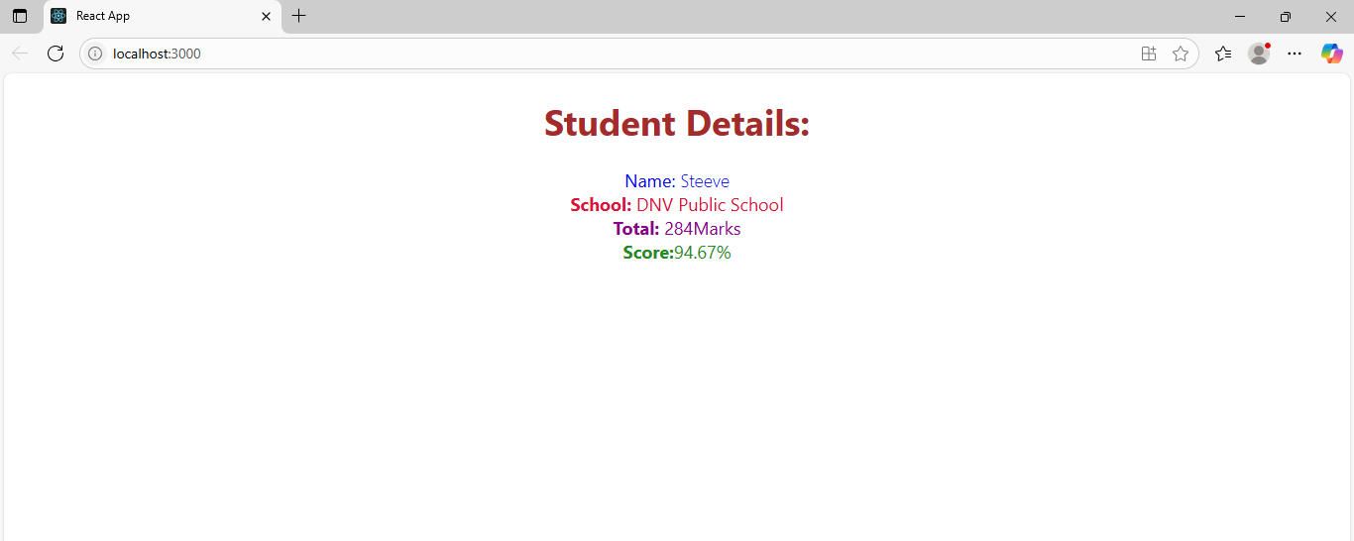

**EXERCISE 4: REACTJS-HOL**

STEP 1: Firstly, we create a React app “blogapp” using the command “npx create-react-app blogapp”.

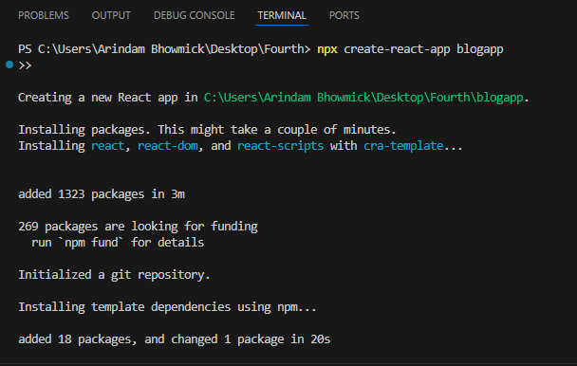

STEP 2: Once the app is created, under the src folder we create a new file named “Post.js”. The code for “Post.js” is shown below

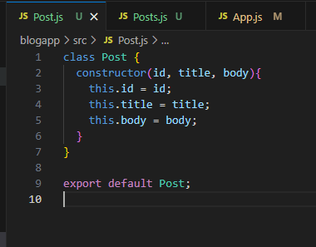

STEP 3: Under src folder we again create another file named “Posts.js”. The code for “Posts.js” is shown below

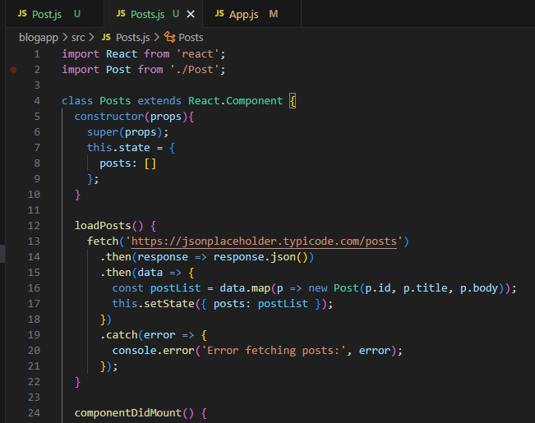

Continued…..

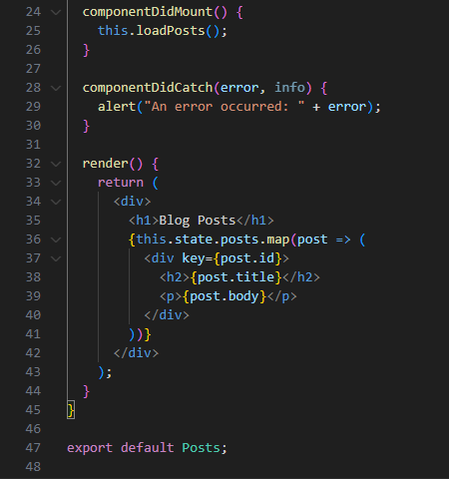

STEP 4: Once this is done, we modify the “App.js” file under src to include and add these sections. The code for “App.js” is shown below

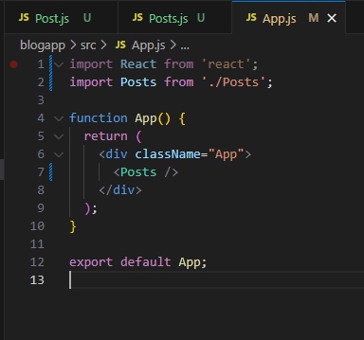

STEP 5: Then we run the React App by using the command “npm start”.

STEP 6: The output is visible in “localhost:3000”. It is shown below

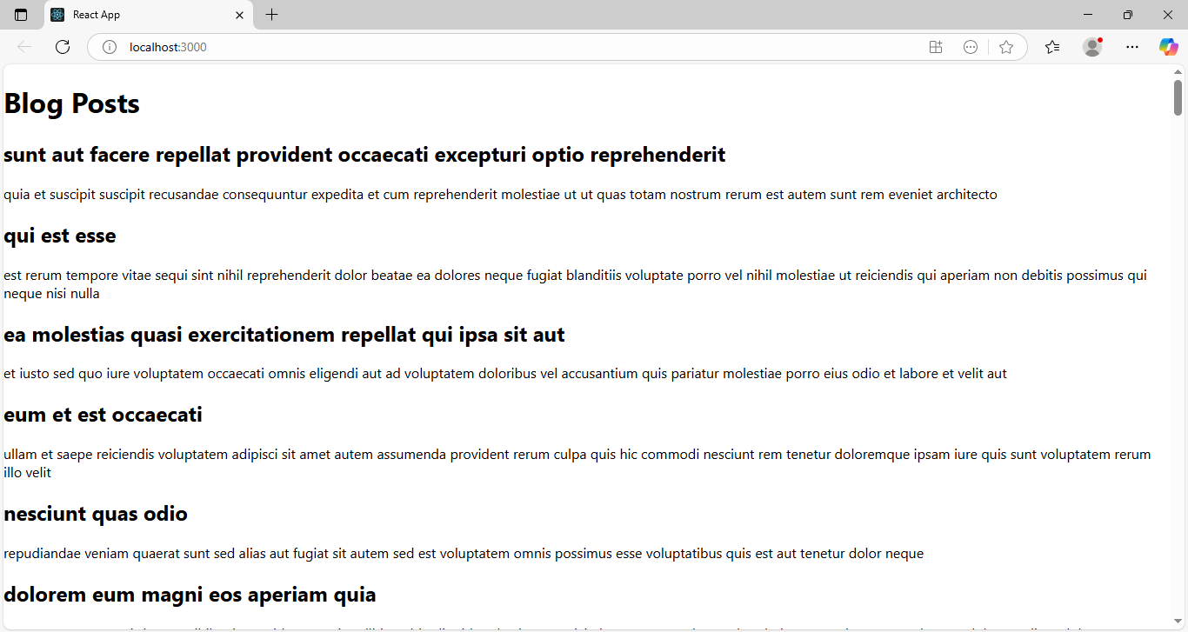

Continued….

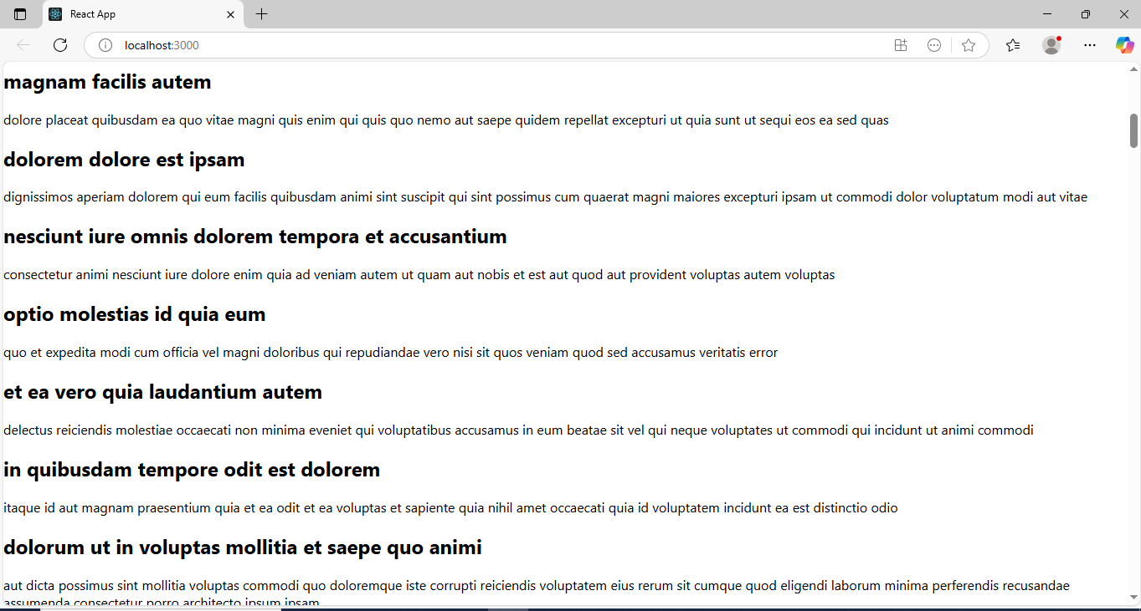

Continued….

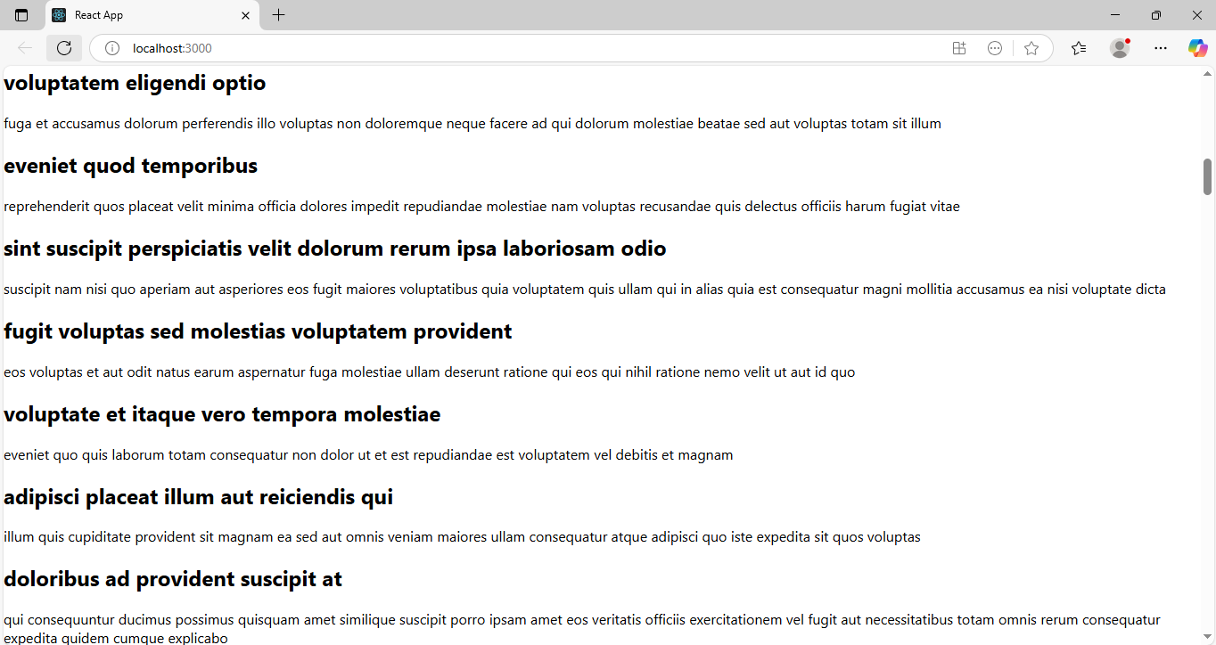

**EXERCISE 5: REACTJS-HOL**

STEP 1: First, we downloaded the React Application in the zip format as was asked to do.

STEP 2: Then we unzipped the folder and added it to our vs code workspace.

STEP 3: Then we used the command “npm install” to download all the dependencies.

STEP 4: After the project got successfully installed, we added a new file named “CohortDetails.module.css” to add the Css for our project. The code for “CohortDetails.module.css” is shown below

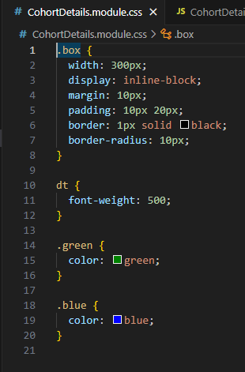

STEP 5: Then we modified the “CohortDetails.js” file to create the project. The code for it is shown below

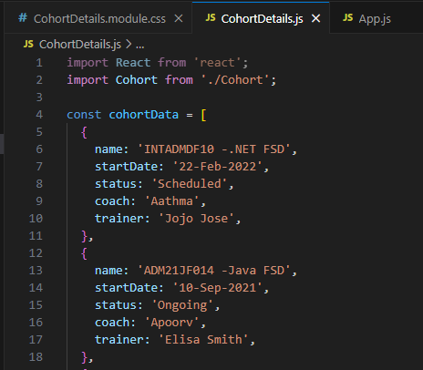

Continued….

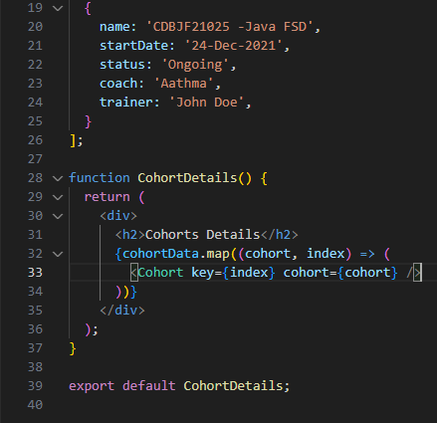

STEP 6: Then we modified the “Cohort.js” file to create the project. The code for it is shown below

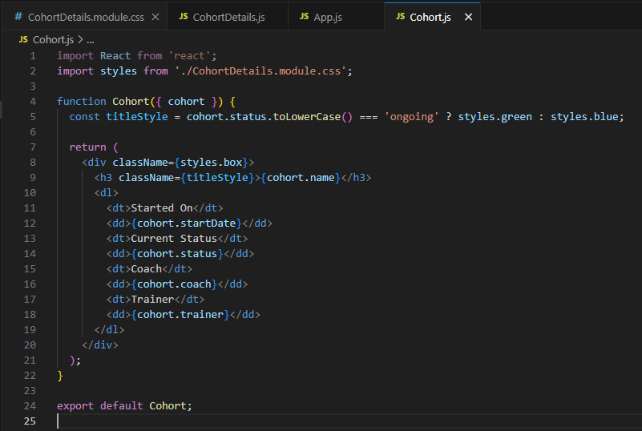

STEP 7: Once this is done, we modify the “App.js” file under src to include and add these sections. The code for “App.js” is shown below

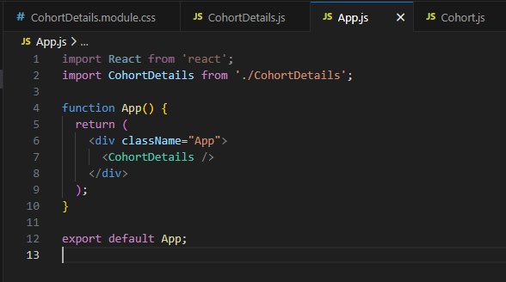

STEP 8: Then we run the React App by using the command “npm start”.

STEP 9: The output is visible in “localhost:3000”. It is shown below.

